**Iowa Liquor Sales- Des Moines in Perspective Using GCP SQL**

This a notebook by Daniel Ochekpe.

This is an exploratory data analysis project with focus on liquor sales in Iowa, in which we uncover insights and trends overtime from the sales of liquor in the geographical area. The notebook shows different queries from extracting data, data manipulation, and checking for duplicates and a lot more.

Let’s jump right in!

**CONTENTS**

1. Data Extraction
2. Data cleaning
3. Exploratory data analysis
4. Data Extraction- Extracted total no of orders for the entire data set.

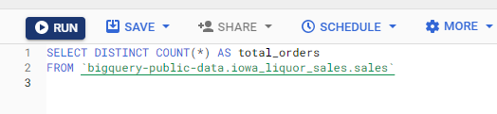

1. Data cleaning- I check for Duplicates and ‘null’ in the dataset

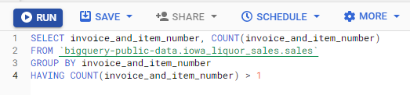

1. Exploratory Data Analysis- I queried to get the start date of sales and the most recent date, and got record of the top 5 highest sales by brand and years that had the highest orders.

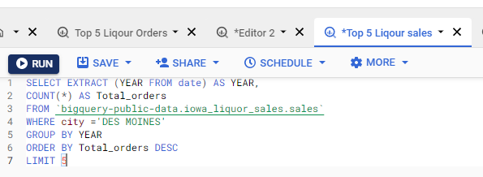

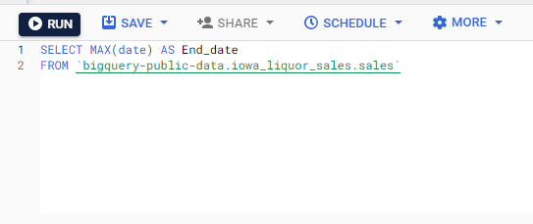

And this query shows the top 5 vendors that grossed revenue the most in the city.

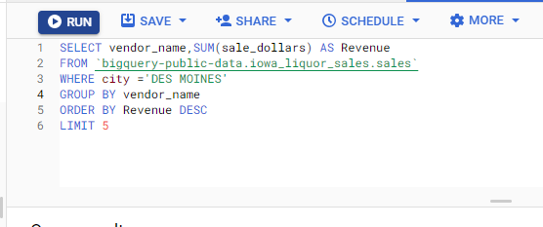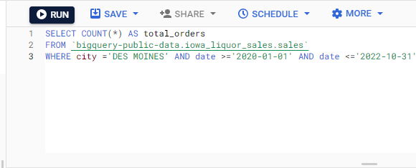

Lastly , this query shows the data extraction of the all the data.

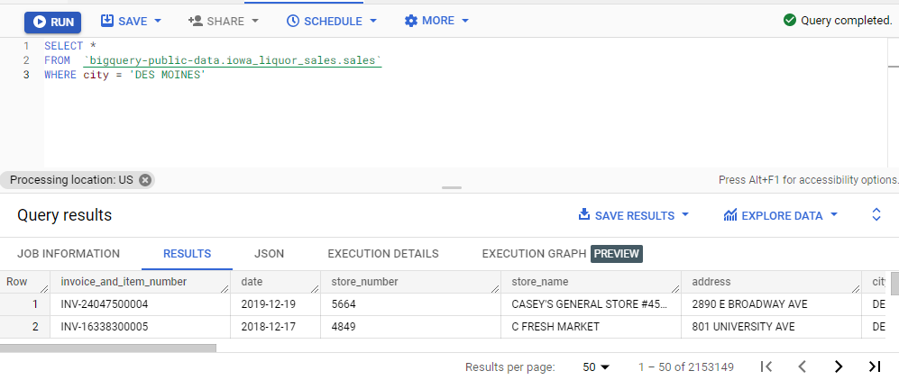

Thank you for your time!